 |  | Region 1 (hospital info)
Discharge Instruction for Colonoscopy  Region 2 (patient instruction) |  |  | - Normal Colon  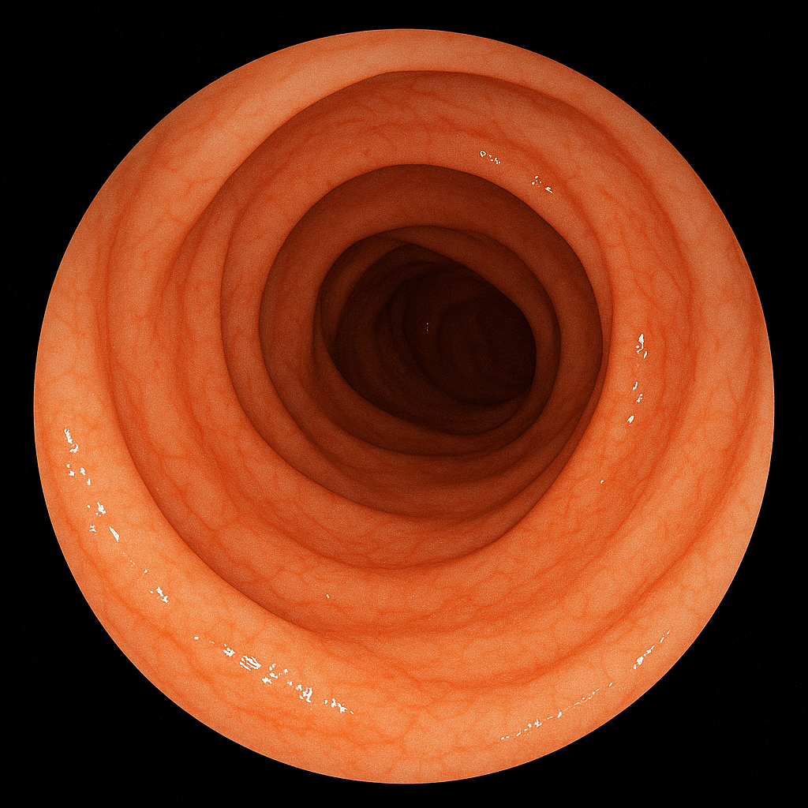
- Colon
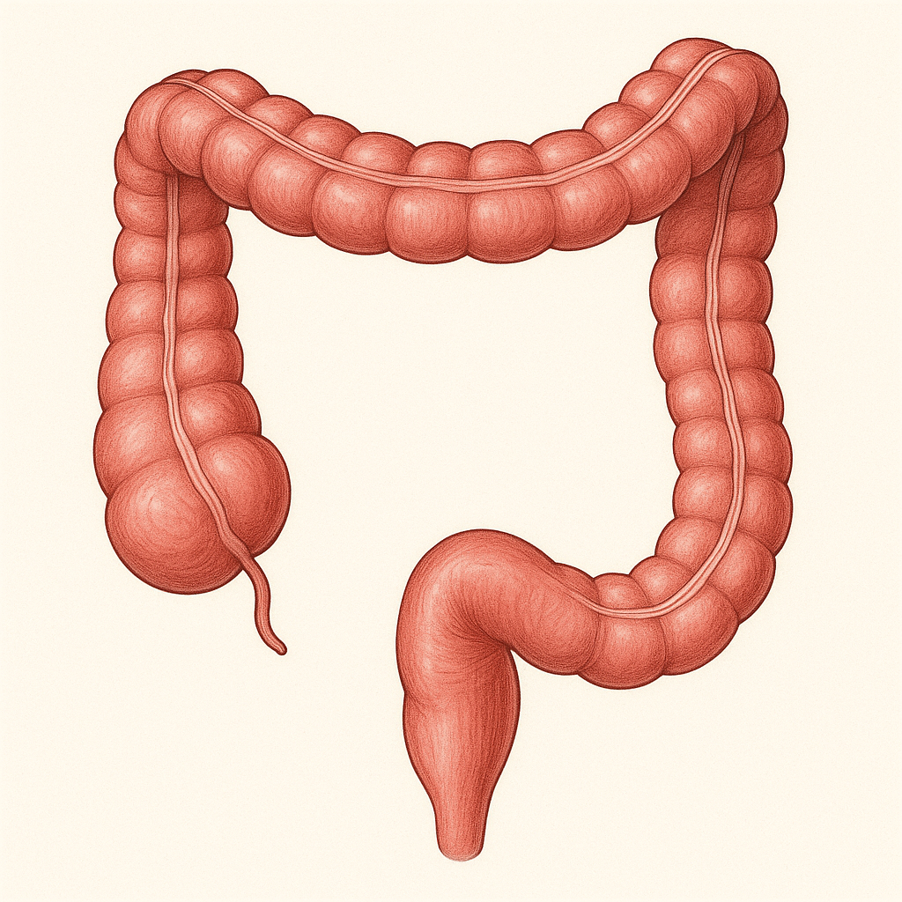
Region 3 (Impressions)
Region 4 (additional instructions)

